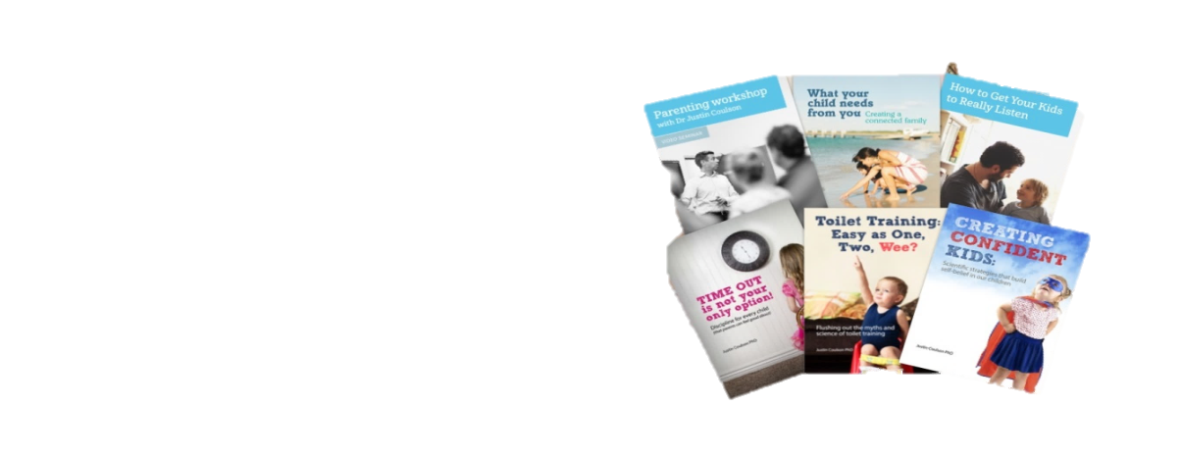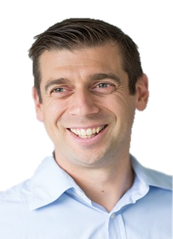

Monday 10 August 7pm Tuesday 11 August 7pm

**St Patrick’s Catholic School OLR Catholic School**

Victoria St, East Gosford Shelly Beach Rd, Shelly Beach

(Primary Campus)

ALL WELCOME

No Cost

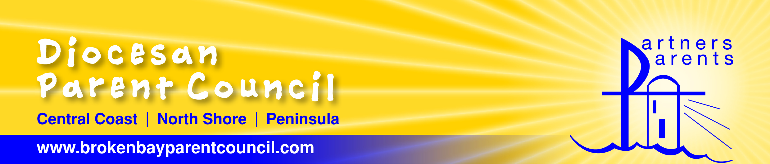

*Proudly presented by…*

Broken Bay Diocesan Parent Council (DPC)

RSVP: [www.brokenbayparentcouncil.com](http://www.brokenbayparentcouncil.com)

*Your School Your P&F Your DPC*



There are endless do’s and don’ts that surround parenting. In this practical seminar, Dr Justin will take you from confusion to clarity by sharing essential strategies to get to the heart of raising a happy child and creating a connected family.

*“Justin is an engaging presenter and an effective communicator. His stories had us laughing and nodding in agreement –*

*he really gets it. His real life examples really do help parents.”*

What Your Child Needs From You

**FREE SEMINAR for**

**Parents & Carers**

**Dr Justin**

**Coulson**

**Dr Justin Coulson**, father of 6, is one of Australia’s most respected parenting speakers, authors and researchers.

He is the founder and owner of ‘Happy Families’ and has written a number of popular books about parenting and happiness.

Dr Justin appears regularly on **The Project and Studio 10**, and he is the parenting expert at **Kidspot** and the **Daily Telegraph**.

**Founder of**

**Happy Families**