Thanks for assisting to promote the upcoming Parent Seminar *Growing Up Online*.

Information below can be ‘cut and pasted’ and used for:

* school newsletters – including Principals / Coordinators message,
* school websites, meetings and assemblies,
* school noticeboards (suggest enlarging flyers/posters to A3),
* emails through teachers/year coordinators/FLO,
* school APPS and social media,

All material can also be downloaded from the DPC website <http://www.brokenbayparentcouncil.com/promoting-social--emotional-seminar.html> with material available as .jpgs that can be hyperlinked, in word and PDF formats.

*Free* Seminar for Parents & Carers:

*The Power of Social & Emotional Skills for Children’s Learning*

The Broken Bay Diocesan Parent Council (DPC) provides seminars and workshops each term for all parents in schools across our diocese. This terms seminar for parents & carers is presented by Jane Nethery.

This seminar will offer information and practical strategies on how to develop social and emotional skills in your child in partnership with your school. Social and emotional learning programs foster children’s academic success and lifelong learning by improving social and emotional skills, attitudes, behaviour and academic performance. Genuine and inclusive school-family partnerships play a crucial role in improving a child’s social and emotional skills.

This informative seminar is being hosted by St Kieran's Catholic School, 63 Gordon Street, Manly Vale on Monday 20 July 7 – 8.30 pm. All parents from schools across our diocese are welcome and there is no cost. To assist with numbers, please go to the DPC website to RSVP [www.brokenbayparentcouncil.com](http://www.brokenbayparentcouncil.com).

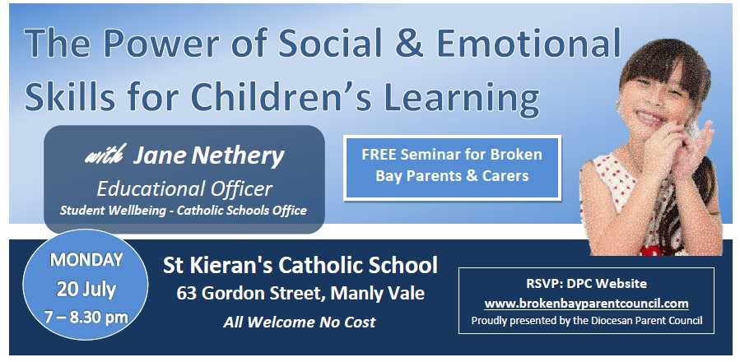

RSVP DPC [WEBSITE](http://www.brokenbayparentcouncil.com/social--emotional-learning.html)

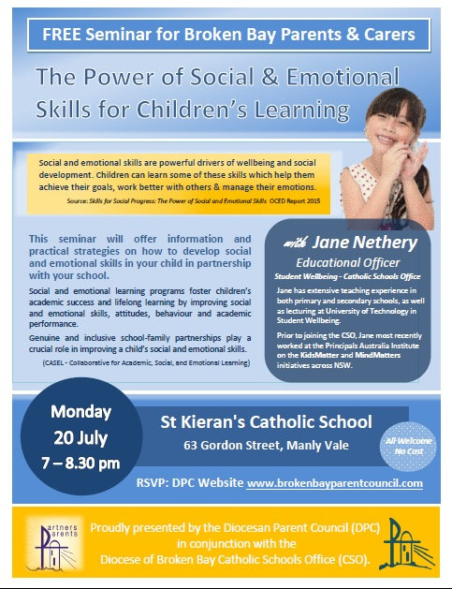

**RSVP DPC** [**WEBSITE**](http://www.brokenbayparentcouncil.com/social--emotional-learning.html)